**ASSIGNMENT 1 –** **PROGRAMMING TECHNIQUE 1 (SECJ1013)**

**ASSIGNMENT 1 - PROGRAMMING TECHNIQUE 1 (SECJ1013)**

**SECTION 07, SEM 1 (2024/2025)**

NAME: ZAHIN IRDINA BINTI MOHD ZABIDY

MATRIC NUMBER: A24CS0216

DATE: 26 OCTOBER 2024

1. **OHM’S LAW CALCULATOR**

The purpose of this calculator is to solve calculations related to The Ohm’s Law whether to find the voltage (V), current (I), resistant (R) or power (P). These are the following formulas related to the law:

V = IR P = I^2 x R

R = I/V P = IV

I = V/R P = V^2 /R

For this calculator specifically, only the SI unit will be used to express each value. Thus, the user must give the input in SI unit as the output will be display in SI unit.

Voltage: Volts

Current: Ampere/A

Resistant: Ohm

Power: Watt

There are three options for the user to choose based on the calculation that they wanted to solve.

Option 1 – To find the resistant and power

Option 2 – To find the current and power

Option 3 – To find the voltage and power

1. 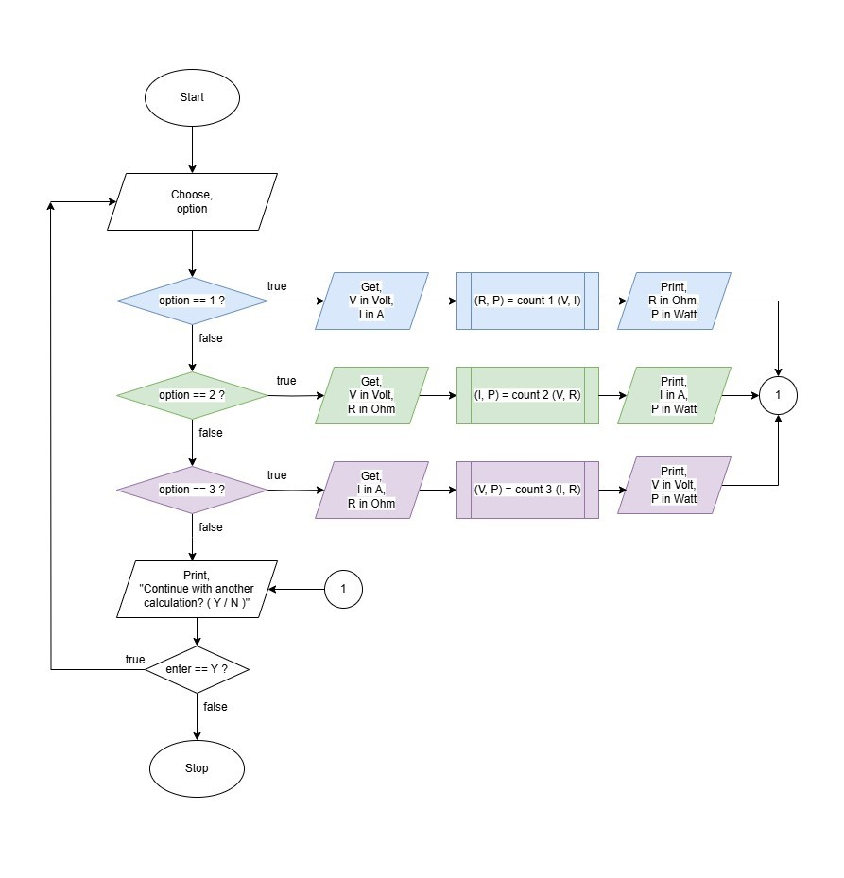**FLOWCHART**

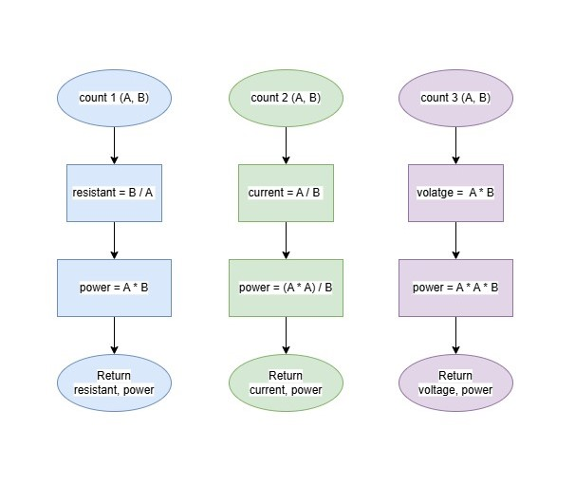

1. 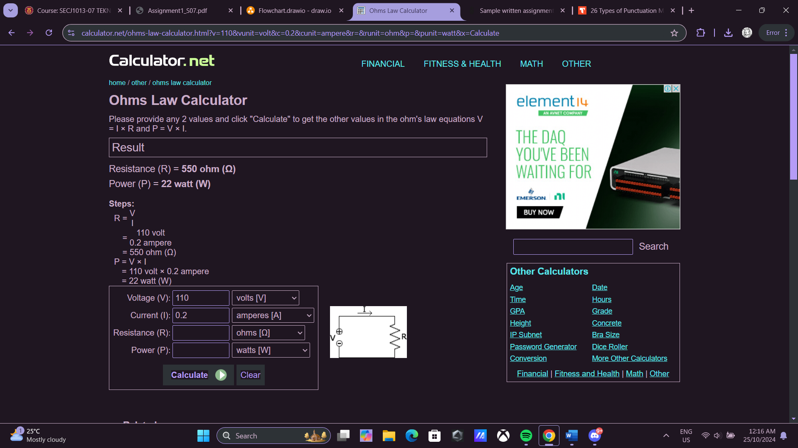**EXAMPLE**

**Figure 1**: Ohm’s Law Calculator application

*(****Source****:* [*https://www.calculator.net/ohms-law-calculator.html*](https://www.calculator.net/ohms-law-calculator.html)*)*

Ohm’s Law Calculator

1. Find resistant and power
2. Find current and power
3. Find voltage and power

Select Option [1 @ 2 @ 3]: **1**

Voltage (Volts): **240**

Current (A): **5**

R=V/I

=240/5

=48

Resistant= 48 Ohm

P=V x I

=240 x 5

=1200

Power= 1200 Watt

Continue with another calculation? [Y @ N]: **N**

Thank you!

**Figure 2**: The example of inputs and outputs